Assignment5 – Behavioral Finance

ChanJung Kim

November 26, 2018

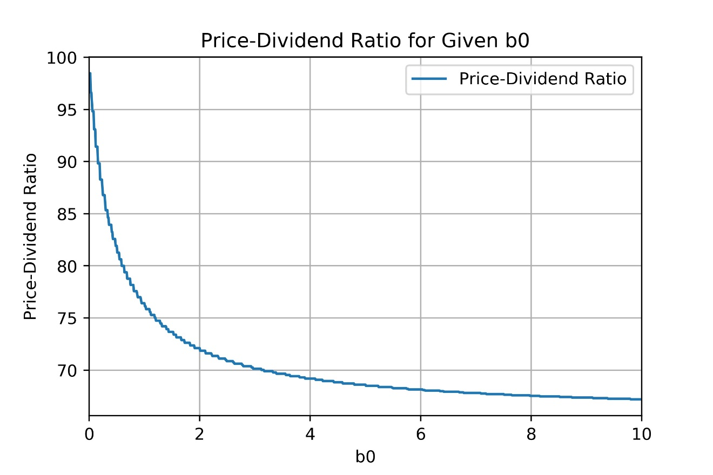1. Price-dividend ratio vs b0

Figure 1 Price-Dividend Ratio for Given b0

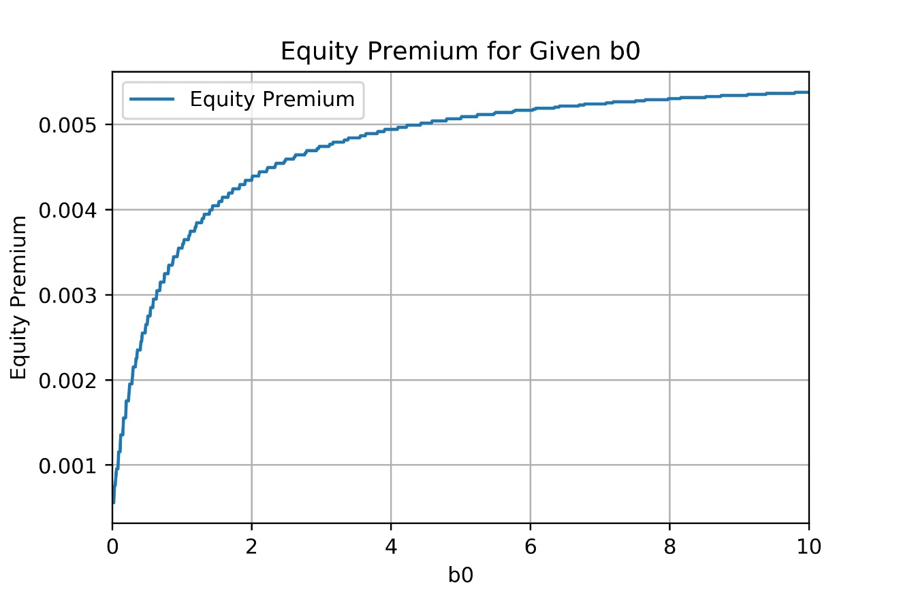2. Equity premium vs b0

Figure 2 Equity Premium for Given b0

3. Economic significance

1. **Investor’s utility function**

The utility function of Berberis, Huang, and Santos is significant in that their utility function incorporated the prospect theory to investors’ utility function. Therefore, using this model, we can explain investor’s psychological influence on the financial decision making which couldn’t be explained in conventional expected utility theory which assumes rational economic man.

The prospect theory was created as a descriptive model of decision making under risk. The prospect theory has two assumptions about how an individual evaluates gains and losses. First, people measure losses and gains based on reference level. Lesser outcome is regarded as loss, while greater outcome is considered as gain. Second, people are loss averse. They are more sensitive to losses than gains of the same magnitude.

As a result, in Berberis, Huang, and Santos’s model, investor’s utility is no more a function of absolute wealth. Instead, an investor’s utility is affected by both the consumption level, and the fluctuations in the value of their financial wealth. What is more, the model can explain how people’s utility changes differently to the same magnitude of loss and gain.

1. **Parameter b0**

When we calculate investors’ utility from consumption and recent financial gains or losses, bt, the scaling factor is multiplied to the utility of recent gains or losses. The reason we multiply bt to the prospect theory term is to make utility of consumption comparable in magnitude to utility of recent gains or losses. Without the scaling factor, the prospect theory term would dominate the constant relative risk term as aggregate wealth grows.

bt is defined as $b_{0}{\overline{C_{t}}}^{-r}$ where b0 is a constant which is greater than or equal to 0. Hence, b0 determines impact of recent gain or loss on investor’s utility. The bigger b0, the greater the influence of prospect theory term in the investors’ utility formula.

1. **Parameter lambda**

Under prospect theory, the utility curve is divided into two parts based on the reference level. As is shown in the below graph, the curve has steeper slope when the outcome goes below reference point. It means that people feel more pain when they have a loss than they feel happiness when they have a gain.

Here, lambda denotes the slope of the curve below reference point. Accordingly, lambda affects how largely people’s utility is changed by losses or gains below reference point. Since people are loss averse in prospect theory, the value of lambda should be greater than one. The greater lambda becomes, the more sensitive people are to the losses.

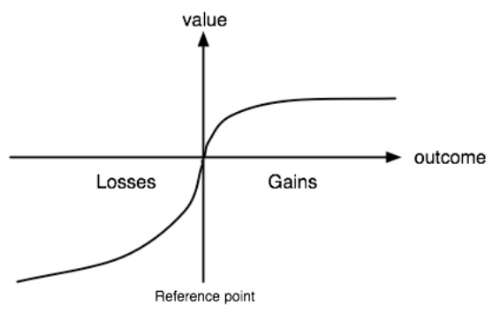

Figure 3 The Relationship between Value and Outcome in the Prospect Theory